Pedigree D-Wurf
Kind of Cool of Joy`s Red Rose Farm "Shadow"  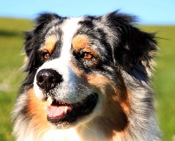  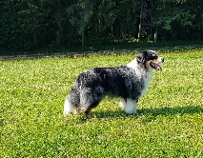 | Koellbachs Big Bodyguard  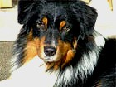 | Legends Smoke`n Brasados Nitani  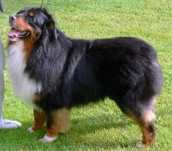
 |  | WS Red Diamonds Jet Set Jelo
 | Beautiful Girl Of Joy`s Red Rose Farm  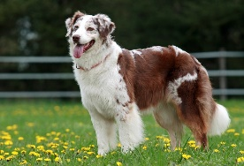 | Trulyawesome Eight Of Hearts  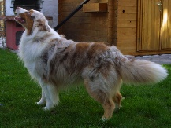
Avalon vom Pinzgauerhof
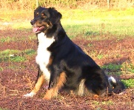
Cassandra Ria od  Haliru  "Lani"  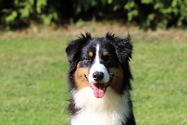  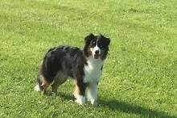 | Legacy`s Breakaway "Buddy"  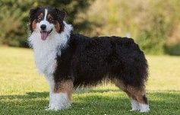 | Legacy`s Fly Right  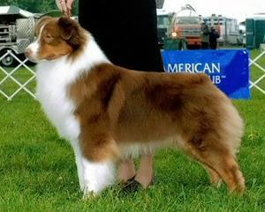
Mill Creek Maka Mega Legacy
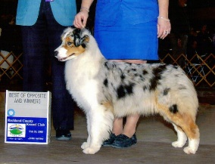
 | Breezy Thorn Valley My Secret Love "Barunka"  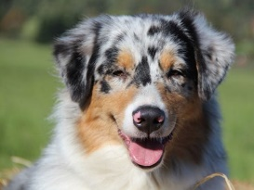 | Thornapple Aftershock  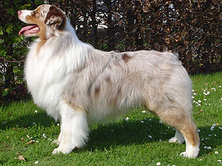
 |  | Thornapple Diamonds at Tiffany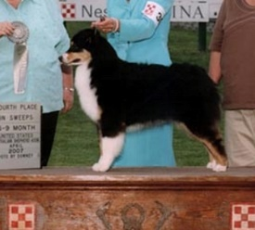

 | Eltern (2. Generation) | Großeltern (3. Generation) | Ur-Großeltern (4. Generation)
Kind Of Cool Of Joy’s Red Rose Farm  "Shadow"  blue-merle c/w | Koellbachs Big Bodyguard DNA-VP | CH Legends Smok 'N Brasados Nitani DNA-VP | CH Legends Rx 4 Success DNA-CP
 | Koellbachs Big Bodyguard DNA-VP | CH Legends Smok 'N Brasados Nitani DNA-VP | CH Ferncrofts Ball of Fire DNA-CP
 | Koellbachs Big Bodyguard DNA-VP | WS Red Diamonds Jet Set Jelo DNA-VP | Rosebud of Crana's Little Twister DNA-CP
 | Koellbachs Big Bodyguard DNA-VP | WS Red Diamonds Jet Set Jelo DNA-VP | CH Kameruns Silk Stocking DNA-CP
 | Beautiful Girl of Joy's Red Rose Farm | CH Trulyawesome Eight of Hearts | CH Aladdin's Gallant Hussar
 | Beautiful Girl of Joy's Red Rose Farm | CH Trulyawesome Eight of Hearts | Trulyawesome Once Upon a Time
 | Beautiful Girl of Joy's Red Rose Farm | Avalon vom Pinzgauer Hof | Green Forest Wakiyan Hotampi
 | Beautiful Girl of Joy's Red Rose Farm | Avalon vom Pinzgauer Hof | American Dream with Ghost-Eyes

